**CLOSE INTERVAL SURVEY & CATHODIC PROTECTION ANNUAL SURVEY OF WEST VIRGINIA MIDSTREAM PIPELINE WV-GLP-0001**

**Coastal 1 Lateral**

**Antero Resources Corporation, Midstream Operations**

*Antero Resources Corp.*

*3677 WV RT 18 S*

*West Union, WV 26456*

**October 2017**

**Prepared For:**

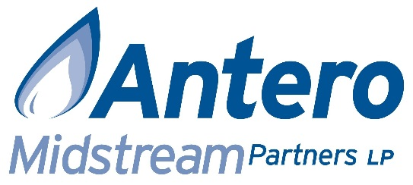

**Prepared By:**



**P.O. Box 794**

**Morgantown, WV 26508**

**_________________________________**

**William J. Hudak Jr., PE, Senior Project Manager**

Disclaimer

This Report was produced by EarthRes Group and is meant to be read as a whole and in conjunction with this disclaimer. Any use of this Report other than as a whole and in conjunction with this disclaimer is forbidden. Any use of this Report outside of its stated purpose without the prior written consent of EarthRes Group is forbidden. Except for its stated purpose, this Report may not be copied or distributed in whole or in part without EarthRes Group’s prior written consent.

This Report and the information and statements herein are based in whole or in part on information obtained from various sources as of July 1, 2017. While EarthRes Group believes such information to be accurate, it makes no assurances, endorsements or warranties, express or implied, as to the validity, accuracy or completeness of any such information, any conclusions based thereon, or any methods disclosed in this Report. EarthRes Group assumes no responsibility for the results of any actions or inactions taken on the basis of this Report. By a party using, acting or relying on this Report, such party consents and agrees that EarthRes Group, its employees, directors, officers, contractors, advisors, members, affiliates, successors and agents shall have no liability with respect to such use, actions, inactions, or reliance.

Table of Contents

1. Executive Summary 4

2. Project Background 5

Appendix A1: CIS Summary 6

Appendix A2: CP Annuals 9

Appendix A3: Project Personnel 10

# Executive Summary

EarthRes performed a cathodic protection close-interval survey (CIS) and a cathodic protection annual survey during the year of 2017 on gas pipelines in Antero Midstream’s West Virginia network. The designated pipeline of these surveys is included in Table 1.

Table 1: Inspected Pipelines

|  |  |
| --- | --- |
| Antero Smart Number | Antero Pipeline Name |
| WV-GLP-0001 | Coastal 1 Lateral |

The Coastal 1 Lateral was inspected on 7/1/2017. Results of the inspection indicate there are two test stations on the 0.42 mile pipeline. Of the two test stations, one was in good condition and one was damaged. Multiple unused anodes are available inside the test stations. There are three attached magnesium anodes protecting the pipeline. There were six total isolation flanges present including three at the pad and three at the interchange. Flange isolation repairs are recommended at the pad and interchange. The cathodic protection readings on the pipeline met acceptance criteria. The summary charts for the CIS can be found in Appendix A1. A further description of the issues and the recommended solutions as well as additional field data is located in Appendix A2.

# Project Background

Antero Midstream requested EarthRes perform a cathodic protection test point survey and close-interval-survey (CIS) on several pipelines in West Virginia. The CP annual survey included finding and recording test station locations, numbering and labeling test stations, taking potentials, and noting any damages present. When there was not an adequate number of test stations, direct-to-pipe readings were also recorded. Resistance bond data as well as rectifier data was recorded when present. Finally, isolation flange data was documented whenever present on the pipelines. The surveys were performed in accordance with NACE Standard Practice SP0207.

The purpose of the CIS was to identify the locations of direct-connected buried anodes and identify possible areas of accelerated corrosion. Inspections were performed on the pipeline listed in Table 1. EarthRes used a line locator to locate and mark each pipeline before performing the CIS. EarthRes used a GPS-enabled data collector to record readings over top of the pipe with a typical spacing of ten feet between readings. The data was processed, placed on a graph, and analyzed for identifying key points of interest. Typical data from the CIS allowed EarthRes to locate buried anodes, identify areas of foreign cathodic protection influence, and identify pipelines or sections of pipeline with insufficient corrosion protection. A GIS shapefile and Google Earth KMZ file are provided containing the data details of the survey.

**Cathodic Protection Criteria:** All potential levels measured and recorded are compared to the criteria for cathodic protection (CP) as established by the DOT and National Association of Corrosion Engineers standard SP0169-2013 Section 6, Subsection 6.2. which states:

1. *A minimum of 100 mV of cathodic polarization. Either the formation or the decay of polarization must be measured to satisfy this criterion.*
2. *A structure-to-electrolyte potential of -850 mV or more negative as measured with respect to a saturated copper/copper sulfate (CSE) reference electrode.*

Field data was collected using a sub-meter or 2-5m accuracy GPS data logger, a high-impedance voltmeter, an insulation checker, and a lab-calibrated Copper-Copper Sulfate reference electrode. Insulated copper survey wire used for collecting readings was cleaned from right-of-ways after use. EarthRes used this data to determine if the pipelines tested were within the acceptance criteria and to provide a list of issues and recommended solutions.

Priority rankings:

* *High*-Corrosion protection is compromised and timely remedy is necessary
* *Medium­*-Issues that do not affect the immediate integrity of the pipeline
* *Low*-Recommendations for best practice

# Appendix A1: CIS Summary

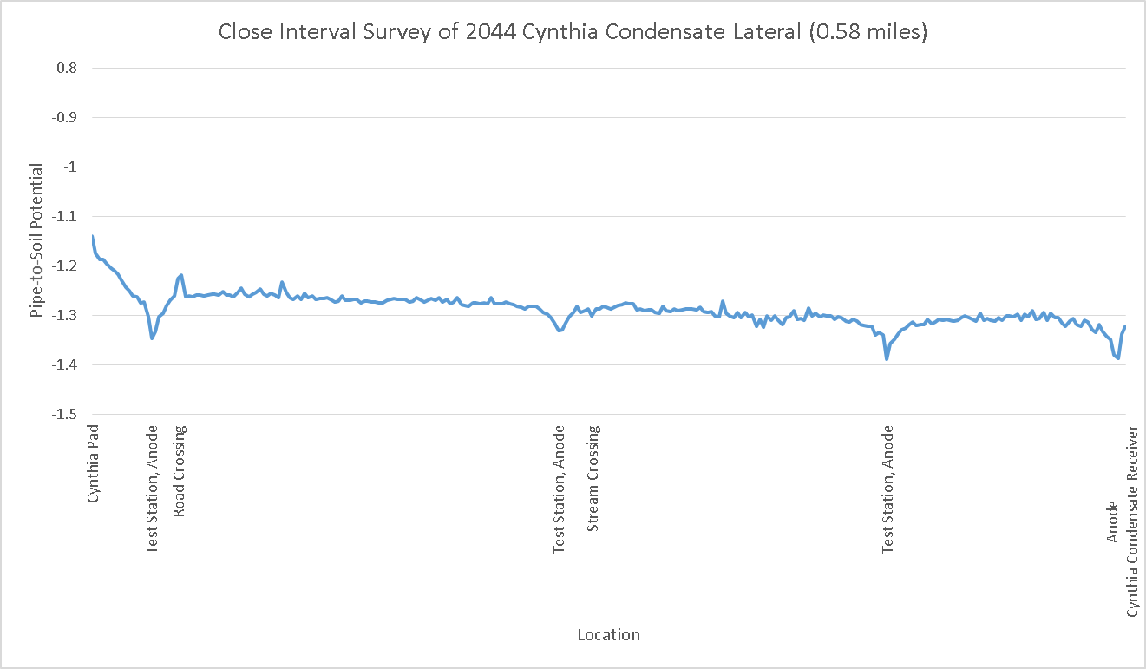

*Figure 1*

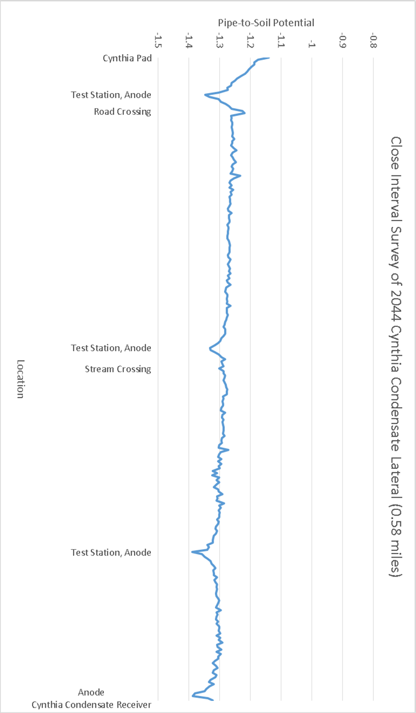

*Figure 2*



*Figure 3*

# Appendix A2: CP Annuals



# Appendix A3: Project Personnel

**William Hudak Jr., P.E.**

Senior Project Manager

**Timothy B. Quetsch, E.I.T.**

Assistant Project Manager

**Jake Westling, E.I.T.**

Staff Engineering

**Ryan King**

Staff Engineering

**Brian O’Neil**

Field Services Technician

**Tom Dodd, Jr.**

Field Services Technician

EarthRes Group, Inc.

[www.earthres.com](http://www.earthres.com/)

(800) 264-4553  
(304) 212-6866